Call for European Heritage Stories: giving the voice to local communities

Launched by European Heritage Days, the Call for European Heritage Stories is a pilot initiative intending to give a voice to the passionate individuals, organisations and associations to tell their story of Europe in the heritage they cherish.

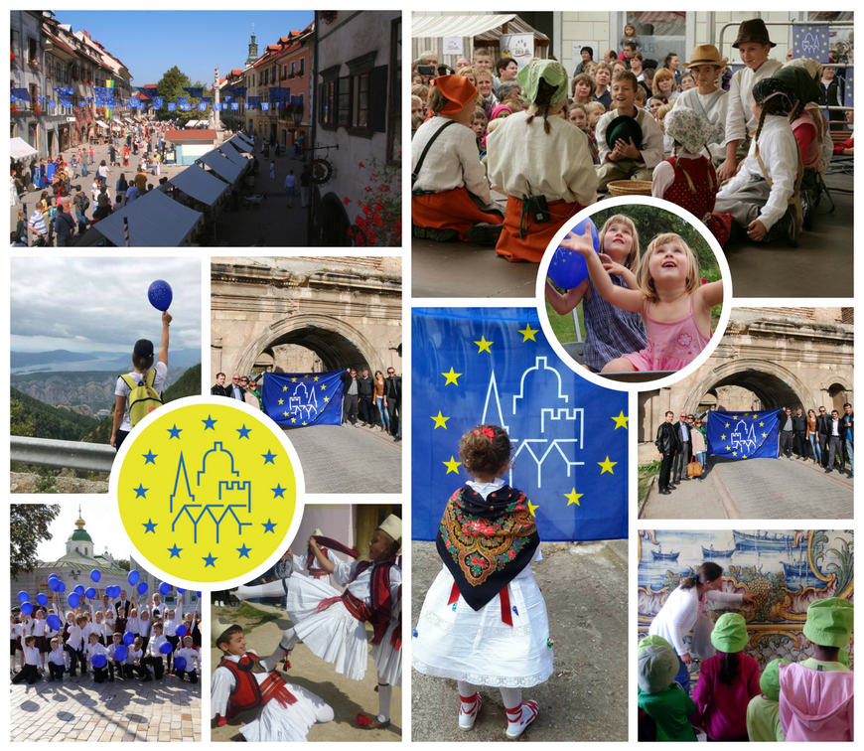
The Call for European Heritage Stories is one of the key initiatives within the European Year of Cultural Heritage (EYCH) 2018, organised under the two slogans: “European Year of Cultural Heritage: The Art of Sharing” and “Our heritage: where the past meets the future”.

Storytellers from EHD communities, EU Prize for Cultural Heritage/Europa Nostra Award winners and the European Heritage Label are invited to share their interpretation of a European heritage story and to explore the ways they understand their heritage site or heritage work corresponds with common European values. In addition to encouraging people to engage with Europe’s cultural heritage and collecting testimonies/stories and good practice on how communities understand the European dimension of local heritage, the Call will give access to direct funding scheme for project proposals connected with the Stories.

Officially launched on 20 April 2018, the storytellers can submit their stories through the Application Form available on the European Heritage Stories page. Each community can submit up to three stories per Call and up to one project proposal to be eligible for the grant procedure (maximum €10 000) connected with one of the submitted stories. A European panel will chose a minimum of 10 European Heritage Stories for a grant to further develop their initiatives.

Stories can be submitted from 20 April to 20 May. Grant applications will then be subject to an additional selection procedure, which will culminate in notification of grant awards in September 2018.

Further information and the application form is available here: http://www.europeanheritagedays.com/European-Heritage-Stories/.

Links and contact information

Organiser: European Heritage Days
Facebook: www.facebook.com/EHDays
Twitter: @JEP_EHD #EHDs
Instagram: @europeanheritagedays #EHDs #JEP

